1. **Implementing Activities using Intents. activity_main.xml:**

*<?*xml version="1.0" encoding="utf-8"*?>*

<androidx.constraintlayout.widget.ConstraintLayout xmlns:android="<http://schemas.android.com/apk/res/android>" xmlns:app="<http://schemas.android.com/apk/res-auto>" xmlns:tools="<http://schemas.android.com/tools>" android:layout_width="match_parent" android:layout_height="match_parent" tools:context=".MainActivity">

<EditText android:id="@+id/name"

android:layout_width="wrap_content" android:layout_height="wrap_content" android:ems="10" android:hint="Name" android:inputType="textPersonName" android:minHeight="48dp"

app:layout_constraintBottom_toBottomOf="parent" app:layout_constraintEnd_toEndOf="parent" app:layout_constraintHorizontal_bias="0.497" app:layout_constraintStart_toStartOf="parent" app:layout_constraintTop_toTopOf="parent" app:layout_constraintVertical_bias="0.179" android:importantForAutofill="no" tools:ignore="HardcodedText" />

<Button

android:id="@+id/login" android:layout_width="wrap_content" android:layout_height="wrap_content" android:text="LOGIN" app:layout_constraintBottom_toBottomOf="parent" app:layout_constraintEnd_toEndOf="parent" app:layout_constraintHorizontal_bias="0.498" app:layout_constraintStart_toStartOf="parent" app:layout_constraintTop_toBottomOf="@+id/name" app:layout_constraintVertical_bias="0.413"

tools:ignore="HardcodedText" />

<EditText android:id="@+id/pwd"

android:layout_width="wrap_content" android:layout_height="wrap_content" android:ems="10" android:hint="Password" android:inputType="textPassword"

app:layout_constraintBottom_toBottomOf="parent" app:layout_constraintEnd_toEndOf="parent" app:layout_constraintHorizontal_bias="0.497" app:layout_constraintStart_toStartOf="parent" app:layout_constraintTop_toTopOf="parent"

app:layout_constraintVertical_bias="0.37" tools:ignore="Autofill,HardcodedText,TouchTargetSizeCheck" />

</androidx.constraintlayout.widget.ConstraintLayout>

**activity_sndpg.xml:**

*<?*xml version="1.0" encoding="utf-8"*?>*

<androidx.constraintlayout.widget.ConstraintLayout xmlns:android="<http://schemas.android.com/apk/res/android>" xmlns:app="<http://schemas.android.com/apk/res-auto>" xmlns:tools="<http://schemas.android.com/tools>" android:layout_width="match_parent" android:layout_height="match_parent" tools:context=".secondpg">

<TextView android:id="@+id/result"

android:layout_width="wrap_content" android:layout_height="wrap_content" android:text="@string/textview1" android:textSize="30sp" app:layout_constraintBottom_toBottomOf="parent" app:layout_constraintEnd_toEndOf="parent" app:layout_constraintHorizontal_bias="0.494" app:layout_constraintStart_toStartOf="parent" app:layout_constraintTop_toTopOf="parent" app:layout_constraintVertical_bias="0.224" android:textColor="@color/black"/>

<TextView android:id="@+id/textView2" android:layout_width="wrap_content" android:layout_height="wrap_content" android:text="Welcome!"

app:layout_constraintBottom_toBottomOf="parent" app:layout_constraintEnd_toEndOf="parent" app:layout_constraintHorizontal_bias="0.498" app:layout_constraintStart_toStartOf="parent" app:layout_constraintTop_toTopOf="parent" app:layout_constraintVertical_bias="0.141" android:textSize="30sp" android:textColor="@color/black" tools:ignore="HardcodedText" />

</androidx.constraintlayout.widget.ConstraintLayout>

**MainActivity.java:**

package com.example.login; import android.content.Intent; import android.os.Bundle; import android.widget.Button; import android.widget.EditText;

import androidx.appcompat.app.AppCompatActivity; public class MainActivity extends AppCompatActivity {

public static final String *EXTRA_TEXT* = "com.example.application.example.EXTRA_TEXT";

Button but; @Override

protected void onCreate(Bundle savedInstanceState) { super.onCreate(savedInstanceState); setContentView(R.layout.*activity_main*);

but = findViewById(R.id.*login*); but.setOnClickListener(v -> activity2());

}

public void activity2(){

EditText editTextName= findViewById(R.id.*name*); String text =editTextName.getText().toString(); Intent intent = new Intent(this, secondpg.class); intent.putExtra(*EXTRA_TEXT*,text); startActivity(intent);

}

}

**Secondpage.java:**

package com.example.login; import android.content.Intent; import android.os.Bundle; import android.widget.TextView;

import androidx.appcompat.app.AppCompatActivity; public class secondpg extends AppCompatActivity {

@Override

protected void onCreate(Bundle savedInstanceState) { super.onCreate(savedInstanceState); setContentView(R.layout.*activity_secondpg*);

Intent intent= getIntent();

String text= intent.getStringExtra(com.example.login.MainActivity.*EXTRA_TEXT*); TextView res= findViewById(R.id.*result*);

res.setText(text);

}

}

**Input screen:**

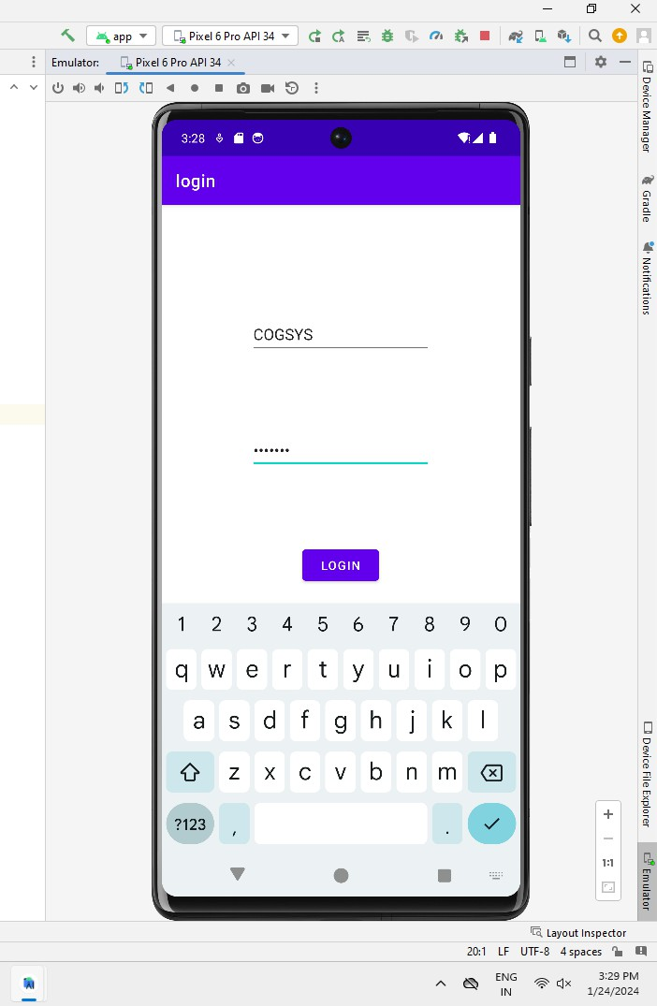

**Output screen:**

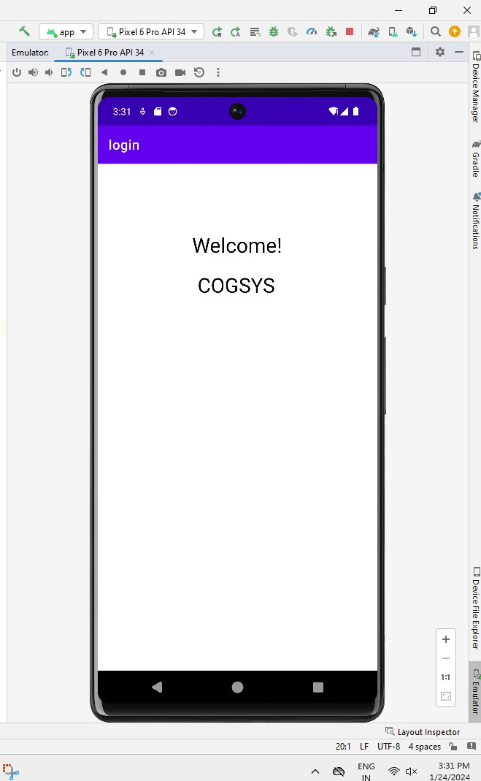

1. **Develope an Application to set an image as wallpaper and on click of a button the image should start to change randomly**

**Activity_main.xml**

*<?*xml version="1.0" encoding="utf-8"*?>*

<RelativeLayout xmlns:android="<http://schemas.android.com/apk/res/android>" xmlns:tools="<http://schemas.android.com/tools>" android:layout_width="match_parent" android:layout_height="match_parent"

tools:context=".MainActivity">

<ImageView android:id="@+id/imageView" android:layout_width="match_parent" android:layout_height="match_parent" android:scaleType="centerCrop" />

<Button

android:id="@+id/changeWallpaperButton" android:layout_width="wrap_content" android:layout_height="wrap_content" android:layout_centerHorizontal="true" android:layout_alignParentBottom="true" android:layout_marginBottom="16dp" android:text="Change Wallpaper" />

</RelativeLayout>

**MainActivity.java:**

package com.example.activity.wallpaperchange; import android.Manifest;

import android.annotation.SuppressLint; import android.app.WallpaperManager; import android.content.pm.PackageManager; import android.os.Build;

import android.os.Bundle; import android.view.View; import android.widget.Button;

import android.widget.ImageView; import androidx.annotation.NonNull;

import androidx.appcompat.app.AppCompatActivity; import androidx.core.app.ActivityCompat;

import androidx.core.content.ContextCompat; import com.example.activity.wallpaperchange.R; import java.io.IOException;

import java.util.Random;

public class MainActivity extends AppCompatActivity {

private static final int *REQUEST_CODE_PERMISSION* = 123; private ImageView imageView;

private Button changeWallpaperButton; private int[] wallpaperImages = {

R.drawable.*wallpaper1*, R.drawable.*wallpaper2*, R.drawable.*wallpaper3*

*// Add more wallpaper images as needed*

};

@Override

protected void onCreate(Bundle savedInstanceState) { super.onCreate(savedInstanceState); setContentView(R.layout.*activity_main*); imageView = findViewById(R.id.*imageView*);

changeWallpaperButton = findViewById(R.id.*changeWallpaperButton*);

*// Set initial wallpaper*

setRandomWallpaper();

*// Set click listener for the button*

changeWallpaperButton.setOnClickListener(new View.OnClickListener() { @Override

public void onClick(View v) {

*// Change wallpaper on button click*

setRandomWallpaper();

}

});

*// Request permission if not granted*

requestPermission();

}

private void requestPermission() {

if (Build.VERSION.*SDK_INT* >= Build.VERSION_CODES.*M* &&

ContextCompat.*checkSelfPermission*(this, Manifest.permission.*SET_WALLPAPER*)

!= PackageManager.*PERMISSION_GRANTED*) { ActivityCompat.*requestPermissions*(

this,

new String[]{Manifest.permission.*SET_WALLPAPER*},

*REQUEST_CODE_PERMISSION*

);

}

}

@SuppressLint("MissingSuperCall") @Override

public void onRequestPermissionsResult(int requestCode, @NonNull String[] permissions, @NonNull int[] grantResults) {

if (requestCode == *REQUEST_CODE_PERMISSION* && grantResults.length > 0 && grantResults[0] == PackageManager.*PERMISSION_GRANTED*) {

*// Permission granted*

}

}

private void setRandomWallpaper() {

*// Choose a random wallpaper image*

int randomIndex = new Random().nextInt(wallpaperImages.length); int resourceId = wallpaperImages[randomIndex];

*// Set the chosen image as wallpaper*

try {

WallpaperManager.*getInstance*(this).setResource(resourceId);

} catch (IOException e) { e.printStackTrace();

}

*// Set the chosen image in the ImageView*

imageView.setImageResource(resourceId);

}

}

**Input screen:**

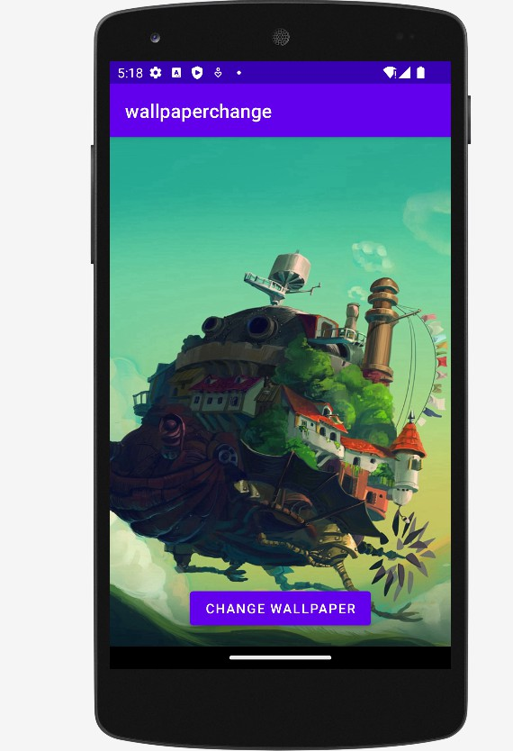

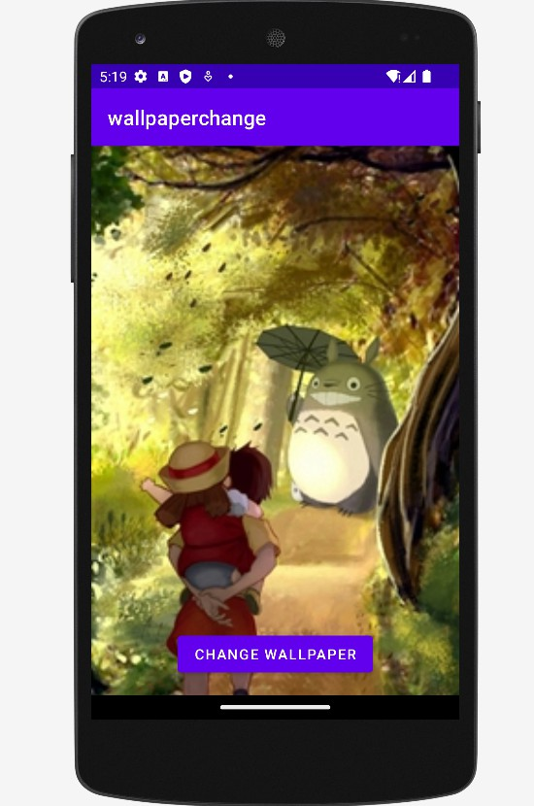

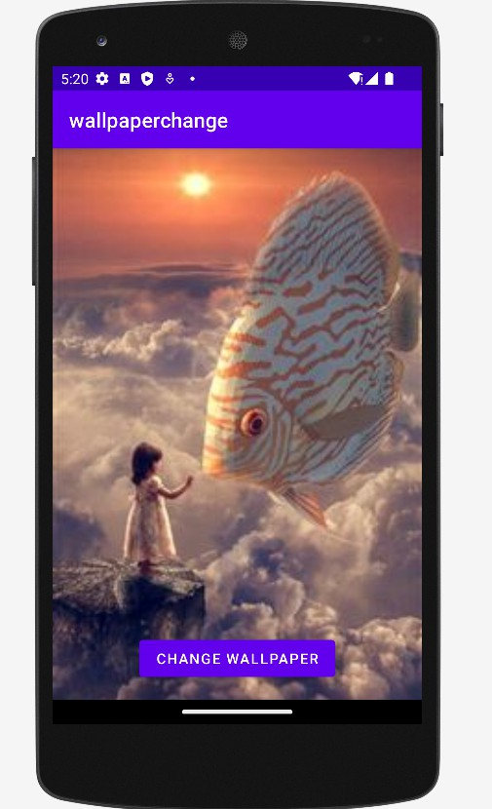

**Output screen:**

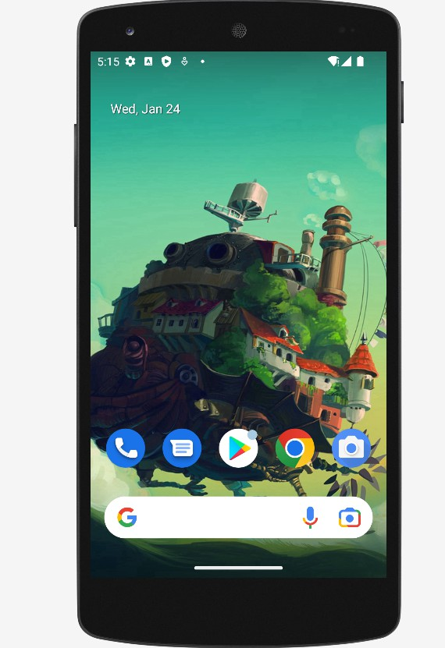

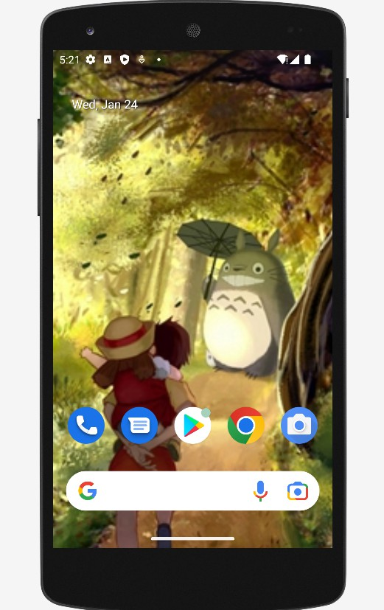

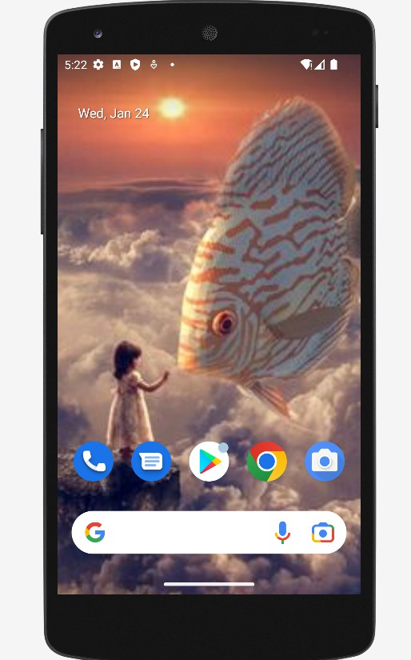

1. **Implementing UI component using various view layout**

**activity_main.xml**

*<?*xml version="1.0" encoding="utf-8"*?>*

<LinearLayout xmlns:android="<http://schemas.android.com/apk/res/android>" xmlns:tools="<http://schemas.android.com/tools>" android:layout_width="match_parent" android:layout_height="match_parent" android:orientation="vertical"

android:padding="16dp">

<ImageView android:id="@+id/profileImage" android:layout_width="150dp" android:layout_height="150dp" android:layout_gravity="center" android:layout_marginBottom="16dp"

android:src="@drawable/ic_launcher_foreground" tools:ignore="ContentDescription,ImageContrastCheck" />

<EditText android:id="@+id/editTextName" android:layout_width="375dp" android:layout_height="63dp" android:layout_marginBottom="8dp" android:hint="@string/name" tools:ignore="TextFields" android:importantForAutofill="no" />

<EditText android:id="@+id/editTextEmail" android:layout_width="379dp" android:layout_height="59dp" android:layout_marginBottom="16dp" android:hint="Email" android:inputType="textEmailAddress" android:importantForAutofill="no" tools:ignore="HardcodedText" />

<Button

android:id="@+id/buttonSave" android:layout_width="289dp" android:layout_height="wrap_content" android:text="@string/save_changes" />

</LinearLayout>

**MainActivity.java:**

package com.example.myapplication; import android.os.Bundle;

import android.view.View; import android.widget.Button; import android.widget.EditText;

import android.widget.ImageView; import android.widget.Toast;

import android.appcompat.app.AppCompatActivity; public class MainActivity extends AppCompatActivity {

@Override

protected void onCreate(Bundle savedInstanceState) { super.onCreate(savedInstanceState); setContentView(R.layout.*ttt*);

ImageView profileImage = findViewById(R.id.*profileImage*); EditText editTextName = findViewById(R.id.*editTextName*); EditText editTextEmail = findViewById(R.id.*editTextEmail*); Button buttonSave = findViewById(R.id.*buttonSave*); buttonSave.setOnClickListener(new View.OnClickListener() {

@Override

public void onClick(View view) {

String name = editTextName.getText().toString(); String email = editTextEmail.getText().toString();

*// Save logic here (you can replace this with your actual implementation)*

*// Display a toast message for demonstration purposes*

String message = "Name: " + name + "\nEmail: " + email; Toast.*makeText*(MainActivity.this, message, Toast.*LENGTH_SHORT*).show();

}

});

}

}

**Input screen:**

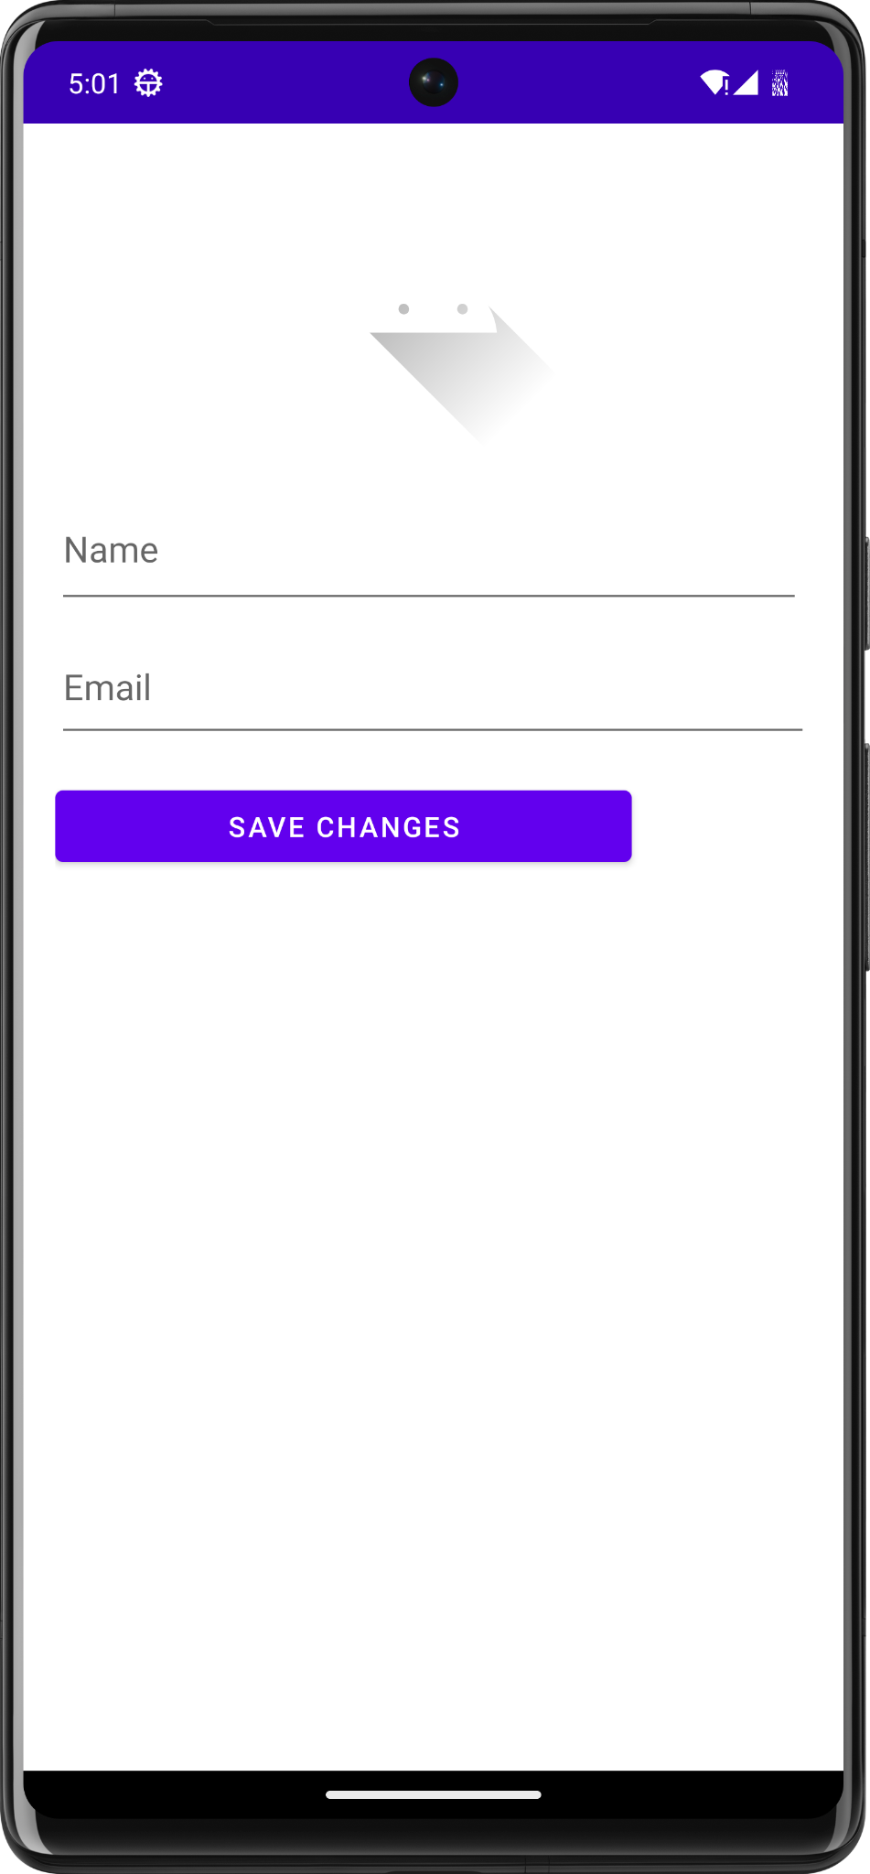

**Output screen:**

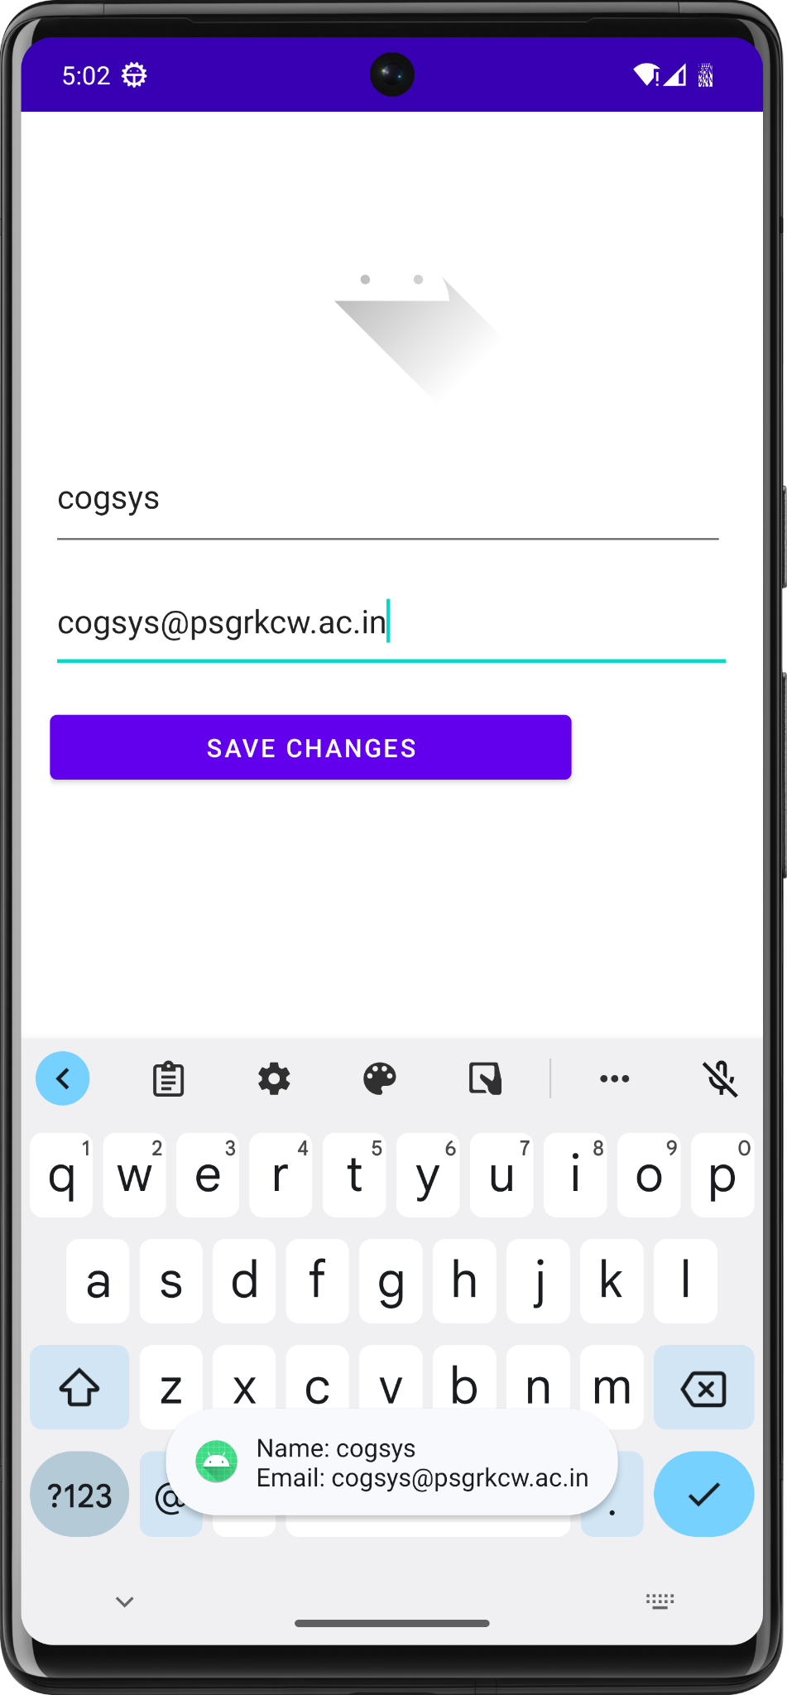

1. **Develop an android application using controls like button, textview, edittext for designing a calculator having basic functionality like addition, subtraction, multiplication and division.**

**activity_main.xml:**

*<?*xml version="1.0" encoding="utf-8"*?>*

<LinearLayout xmlns:android="<http://schemas.android.com/apk/res/android>" xmlns:tools="<http://schemas.android.com/tools>" android:layout_width="match_parent" android:layout_height="match_parent"

android:orientation="vertical" android:padding="16dp" tools:context=".MainActivity">

<EditText android:id="@+id/editText"

android:layout_width="match_parent" android:layout_height="wrap_content" android:layout_marginBottom="16dp" android:hint="0" android:inputType="text" android:textSize="24sp"

tools:ignore="Autofill,DuplicateSpeakableTextCheck,HardcodedText,VisualLintTextFieldSize" />

<GridLayout android:layout_width="match_parent" android:layout_height="wrap_content"

android:background="@color/design_default_color_primary" android:columnCount="4"

android:rowCount="5">

*<!-- Buttons -->*

<Button

style="?android:attr/borderlessButtonStyle" android:onClick="onClearButtonClick" android:text="C" tools:ignore="HardcodedText" />

<Button

style="?android:attr/borderlessButtonStyle" android:onClick="onOperatorClick" android:text="+" tools:ignore="HardcodedText" />

<Button

style="?android:attr/borderlessButtonStyle" android:onClick="onOperatorClick" android:text="-" tools:ignore="HardcodedText" />

<Button

style="?android:attr/borderlessButtonStyle" android:onClick="onOperatorClick" android:text="*" tools:ignore="HardcodedText" />

<Button

style="?android:attr/borderlessButtonStyle" android:onClick="onNumberClick" android:text="1" tools:ignore="HardcodedText" />

<Button

style="?android:attr/borderlessButtonStyle" android:onClick="onNumberClick" android:text="2" tools:ignore="HardcodedText" />

<Button

style="?android:attr/borderlessButtonStyle" android:onClick="onNumberClick" android:text="3" tools:ignore="HardcodedText" />

<Button

style="?android:attr/borderlessButtonStyle" android:onClick="onOperatorClick" android:text="/" tools:ignore="HardcodedText" />

<Button

style="?android:attr/borderlessButtonStyle" android:onClick="onNumberClick" android:text="4" tools:ignore="HardcodedText" />

<Button

style="?android:attr/borderlessButtonStyle" android:onClick="onNumberClick" android:text="5" tools:ignore="HardcodedText" />

<Button

style="?android:attr/borderlessButtonStyle" android:onClick="onNumberClick" android:text="6" tools:ignore="HardcodedText" />

<Button

style="?android:attr/borderlessButtonStyle" android:onClick="onNumberClick" android:text="." tools:ignore="HardcodedText" />

<Button

style="?android:attr/borderlessButtonStyle" android:onClick="onNumberClick" android:text="7" tools:ignore="HardcodedText" />

<Button

style="?android:attr/borderlessButtonStyle" android:onClick="onNumberClick" android:text="8"

tools:ignore="HardcodedText" />

<Button

style="?android:attr/borderlessButtonStyle" android:onClick="onNumberClick" android:text="9" tools:ignore="HardcodedText" />

<Button

style="?android:attr/borderlessButtonStyle" android:onClick="onEqualButtonClick" android:text="="

tools:ignore="DuplicateSpeakableTextCheck,HardcodedText" />

<Button

style="?android:attr/borderlessButtonStyle" android:onClick="onNumberClick" android:text="0" tools:ignore="HardcodedText" />

<Button

style="?android:attr/borderlessButtonStyle" android:layout_columnSpan="2" android:onClick="onEqualButtonClick" android:text="=" tools:ignore="HardcodedText" />

</GridLayout>

</LinearLayout>

**MainActivity.java:**

package com.example.activity.myapplicationcalc; import android.annotation.SuppressLint;

import android.os.Bundle; import android.view.View; import android.widget.Button; import android.widget.EditText;

import androidx.appcompat.app.AppCompatActivity; import org.mariuszgromada.math.mxparser.Expression; public class MainActivity extends AppCompatActivity {

private EditText editText; @Override

protected void onCreate(Bundle savedInstanceState) { super.onCreate(savedInstanceState); setContentView(R.layout.*activity_main*);

editText = findViewById(R.id.*editText*);

}

public void onNumberClick(View view) { Button button = (Button) view; editText.append(button.getText());

}

public void onOperatorClick(View view) { Button button = (Button) view; editText.append(" " + button.getText() + " ");

}

public void onClearButtonClick(View view) { editText.setText("");

}

@SuppressLint("SetTextI18n")

public void onEqualButtonClick(View view) { String expression = editText.getText().toString(); try {

Expression expr = new Expression(expression); double result = expr.calculate(); editText.setText(Double.*toString*(result));

} catch (Exception e) { editText.setText("Error");

}

}

}

**Input screen:**

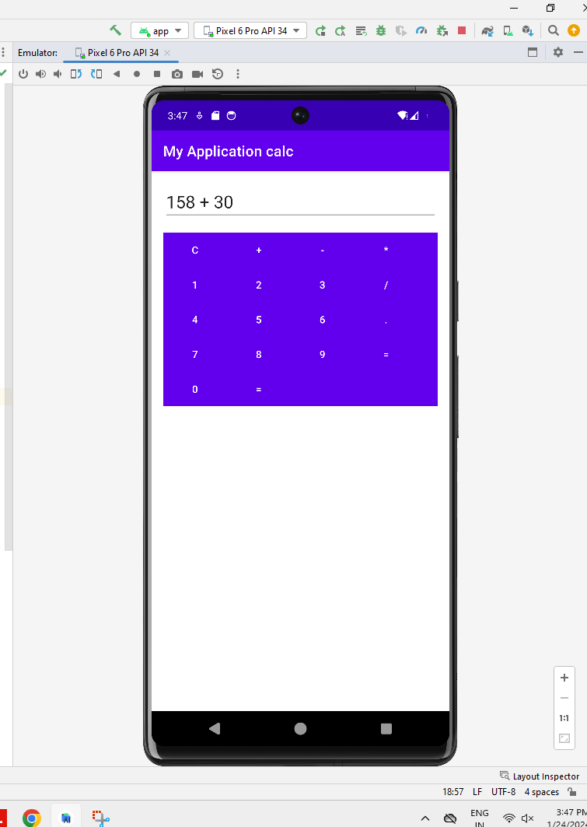

**Output screen:**

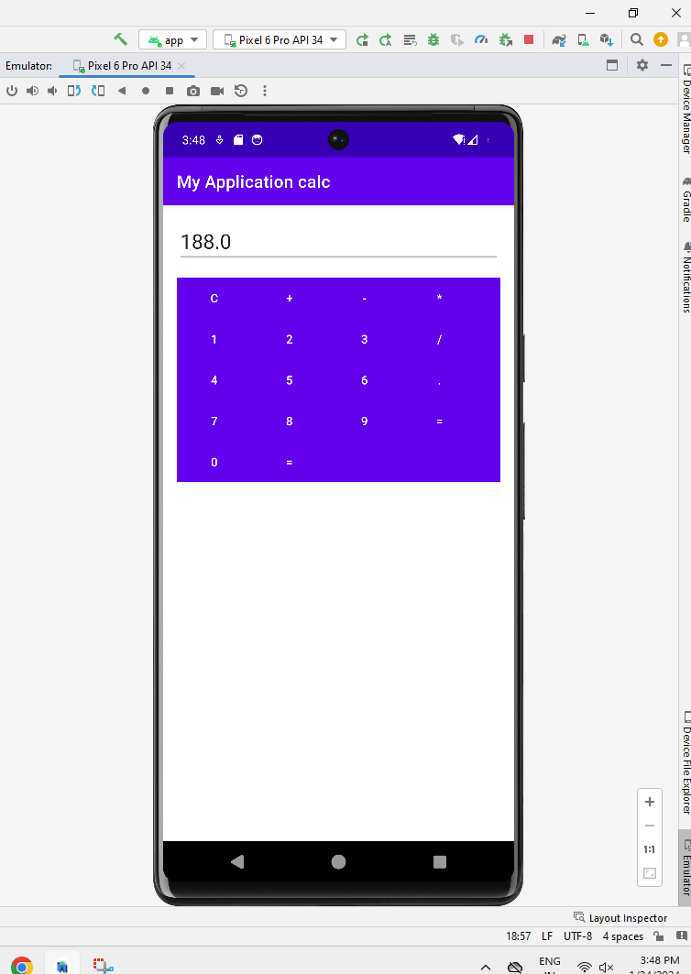

1. **Exercise using controls like Radiogroup,Button and Checkbox.**

**Layout.xml**

*<?*xml version="1.0" encoding="utf-8"*?>*

<LinearLayout xmlns:android="<http://schemas.android.com/apk/res/android>" xmlns:tools="<http://schemas.android.com/tools>" android:orientation="vertical"

android:layout_width="match_parent" android:layout_height="match_parent">

<TextView android:layout_width="match_parent" android:layout_height="wrap_content" android:text="select your subject" android:textStyle="bold" android:textSize="30dp" tools:ignore="HardcodedText,SpUsage" />

<CheckBox android:layout_width="match_parent" android:layout_height="wrap_content" android:id="@+id/tam" android:text="Tamil" android:textSize="25dp" tools:ignore="HardcodedText,SpUsage">

</CheckBox>

<CheckBox android:layout_width="match_parent" android:layout_height="wrap_content" android:id="@+id/eng" android:text="English" android:textSize="25dp" tools:ignore="HardcodedText,SpUsage">

</CheckBox>

<CheckBox android:id="@+id/social"

android:layout_width="match_parent" android:layout_height="wrap_content" android:text="Social" android:textSize="25dp"

tools:ignore="HardcodedText,SpUsage,TextSizeCheck">

</CheckBox>

<CheckBox android:layout_width="match_parent" android:layout_height="wrap_content" android:id="@+id/sci" android:text="Science" android:textSize="25dp" tools:ignore="HardcodedText,SpUsage">

</CheckBox>

<TextView

android:id="@+id/gender" android:layout_width="match_parent" android:layout_height="wrap_content" android:text="Select your Gender" android:textSize="30dp" android:textStyle="bold" tools:ignore="HardcodedText,SpUsage" />

<RadioGroup android:id="@+id/rgGender" android:layout_width="match_parent" android:layout_height="wrap_content" android:orientation="horizontal">

<RadioButton android:id="@+id/male"

android:layout_width="match_parent" android:layout_height="wrap_content" android:layout_weight="1" android:text="Male" android:textSize="25dp"

tools:ignore="HardcodedText,SpUsage,TextSizeCheck" />

<RadioButton android:layout_width="match_parent" android:layout_height="wrap_content" android:layout_weight="1" android:id="@+id/female" android:text="Female" android:textSize="25dp" tools:ignore="HardcodedText,SpUsage" />

</RadioGroup>

<Button

android:layout_width="100dp" android:layout_height="50dp" android:id="@+id/subBtn" android:text="Submit" android:gravity="center" android:layout_gravity="center" tools:ignore="HardcodedText" />

</LinearLayout>

**MainActivity.java:**

package com.example.exercise5;

import androidx.appcompat.app.AppCompatActivity; import android.annotation.SuppressLint;

import android.os.Bundle; import android.util.Log;

import android.widget.CheckBox;

import android.widget.CompoundButton; import android.widget.RadioButton; import android.widget.RadioGroup;

import android.widget.Toast;

public class MainActivity extends AppCompatActivity { String TAG=MainActivity.class.getName();

private CheckBox tam,eng,social,sci; private RadioGroup gender;

@SuppressLint({"MissingSuperCall", "MissingInflatedId"}) @Override

protected void onCreate(Bundle savedInstanceState) { super.onCreate(savedInstanceState); setContentView(R.layout.*layout*);

tam=findViewById(R.id.*tam*); eng=findViewById(R.id.*eng*); social=findViewById(R.id.*social*); sci=findViewById(R.id.*sci*);

tam.setOnCheckedChangeListener(new CompoundButton.OnCheckedChangeListener() { @Override

public void onCheckedChanged(CompoundButton compoundButton, boolean b) { Log.*d*(TAG,tam.getText().toString()+"status"+b); Toast.*makeText*(getApplicationContext(),tam.getText().toString()+" "+b,Toast.*LENGTH_LONG*).show();

}

});

eng.setOnCheckedChangeListener(new CompoundButton.OnCheckedChangeListener() { @Override

public void onCheckedChanged(CompoundButton compoundButton, boolean b) { Log.*d*(TAG,eng.getText().toString()+"status"+b); Toast.*makeText*(getApplicationContext(),eng.getText().toString()+" "+b,Toast.*LENGTH_LONG*).show();

}

});

gender=findViewById(R.id.*rgGender*); gender.setOnCheckedChangeListener((radioGroup, i) -> {

RadioButton radioButton=gender.findViewById(i); String selectedstr=radioButton.getText().toString();

Toast.*makeText*(MainActivity.this, "Yourselection is"+selectedstr,Toast.*LENGTH_LONG*).show();});

}

}

**Input screen:**

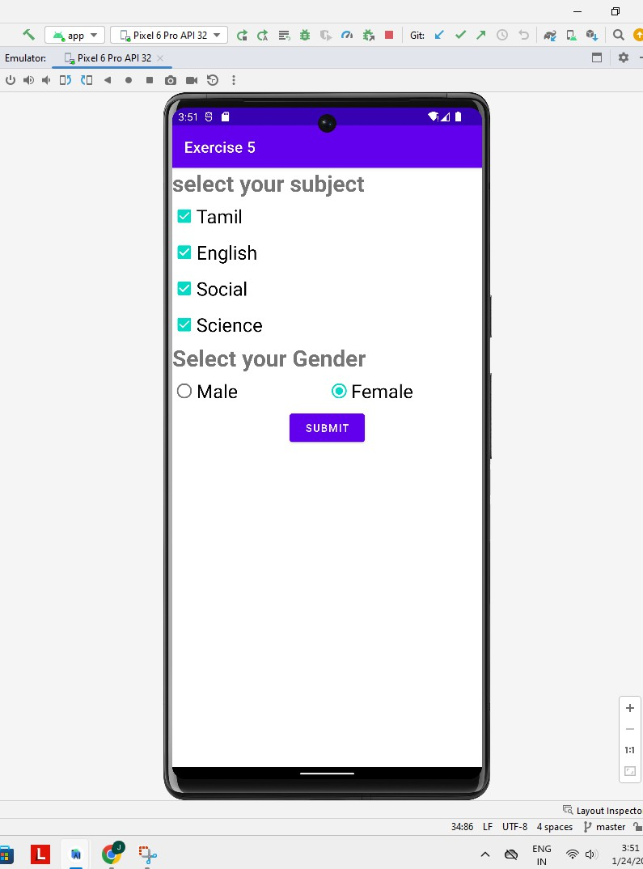

**Output screen:**

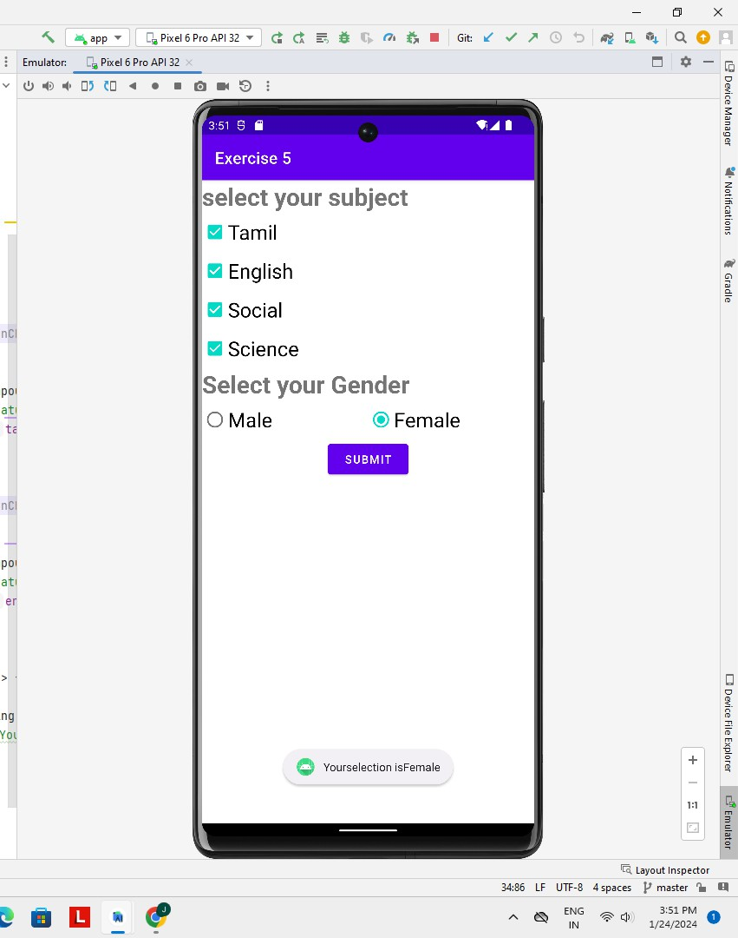

1. **Exercise using ProgressBar view and spinner View**

**activity_main.xml:**

*<?*xml version="1.0" encoding="utf-8"*?>*

<RelativeLayout xmlns:android="<http://schemas.android.com/apk/res/android>" xmlns:tools="<http://schemas.android.com/tools>" android:layout_width="match_parent" android:layout_height="match_parent"

android:paddingLeft="16dp" android:paddingTop="16dp" android:paddingRight="16dp" android:paddingBottom="16dp" tools:context=".MainActivity">

<ProgressBar android:id="@+id/progressBar"

style="?android:attr/progressBarStyleHorizontal" android:layout_width="match_parent" android:layout_height="wrap_content" android:layout_centerVertical="true" android:layout_marginTop="20dp"/>

<Spinner android:id="@+id/spinner"

android:layout_width="match_parent" android:layout_height="wrap_content" android:layout_below="@id/progressBar" android:layout_marginTop="20dp"/>

</RelativeLayout>

**MainActivity.java:**

package com.example.record6;

import android.os.Bundle; import android.view.View;

import android.widget.AdapterView; import android.widget.ArrayAdapter; import android.widget.ProgressBar; import android.widget.Spinner;

import androidx.appcompat.app.AppCompatActivity; import com.example.record6.R;

public class MainActivity extends AppCompatActivity {

private ProgressBar progressBar; private Spinner spinner; @Override

protected void onCreate(Bundle savedInstanceState) { super.onCreate(savedInstanceState); setContentView(R.layout.*activity_main*);

*// Initialize views*

progressBar = findViewById(R.id.*progressBar*); spinner = findViewById(R.id.*spinner*);

*// Set up spinner with sample data*

String[] spinnerItems = {"Level 1", "Level 2", "Level 3", "Level 4", "Level 5"};

ArrayAdapter<String> adapter = new ArrayAdapter<>(this, android.R.layout.*simple_spinner_dropdown_item*, spinnerItems);

spinner.setAdapter(adapter);

*// Set a listener for spinner item selection*

spinner.setOnItemSelectedListener(new AdapterView.OnItemSelectedListener() { @Override

public void onItemSelected(AdapterView<?> parentView, View selectedItemView, int position, long id) {

*// Update progress bar based on the selected item* int progress = (position + 1) * 20; progressBar.setProgress(progress);

}

@Override

public void onNothingSelected(AdapterView<?> parentView) {

*// Do nothing here*

}

});

}

}

**Input screen:**

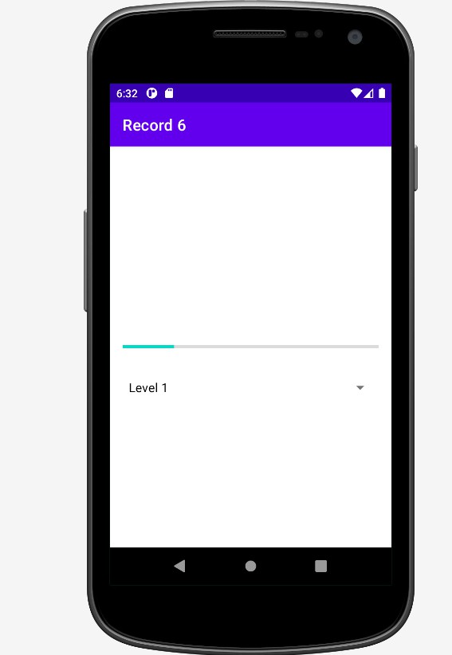

**Output screen:**

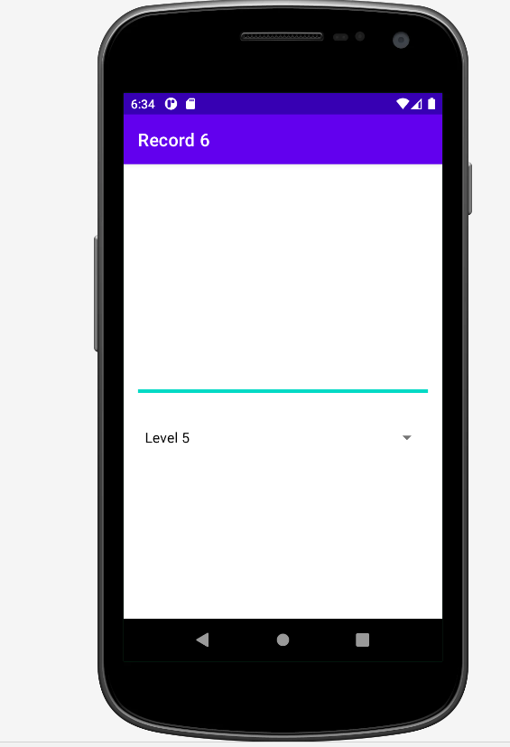

1. **Exercise using ImageView and TextView.**

**activity_main.xml:**

*<?*xml version="1.0" encoding="utf-8"*?>*

<RelativeLayout xmlns:android="<http://schemas.android.com/apk/res/android>" xmlns:tools="<http://schemas.android.com/tools>" android:layout_width="match_parent" android:layout_height="match_parent" android:background="@color/teal_200"

tools:context=".MainActivity">

*<!-- ImageView to display an image -->*

<ImageView android:id="@+id/myImageView" android:layout_width="200dp" android:layout_height="200dp" android:layout_alignParentTop="true" android:layout_centerHorizontal="true" android:layout_marginTop="50dp" android:src="@drawable/img1" />

*<!-- TextView to display text -->*

<TextView android:id="@+id/myTextView" android:layout_width="wrap_content" android:layout_height="wrap_content"

android:layout_below="@id/myImageView" android:layout_alignParentStart="true" android:layout_alignParentEnd="true" android:layout_alignParentBottom="true" android:layout_marginStart="20dp" android:layout_marginTop="103dp" android:layout_marginEnd="15dp" android:layout_marginBottom="342dp" android:text="WELCOME TO ANDROID STUDIO !"

android:textColor="@color/black" android:textSize="25sp" />

</RelativeLayout>

**MainActivity.java:**

package com.example.textviewandimage;

import androidx.appcompat.app.AppCompatActivity; import android.os.Bundle;

import com.example.textviewandimage.R;

public class MainActivity extends AppCompatActivity { @Override

protected void onCreate(Bundle savedInstanceState) { super.onCreate(savedInstanceState); setContentView(R.layout.*activity_main*);

}

**OUTPUT SCREEN::**

